NARRATIVE AND FINANCIAL REPORT FOR ACTIVITIES UNDERTAKEN IN 2017 Yr 1 and Yr 2

Project: #ArmsFreeAfrica - Advancing the Arms Trade Treaty in Africa

TOTAL Amount: 300,000 NOK (275,000 NOK / $32,472.33 USD Received to date; 25,000 NOK Remaining)

Dates: July 2016 - Dec 2017

YEAR 1

Amount: 175,000 NOK ($20,718.69 USD received)

Dates: July – Dec 2016

Activities: In 2016, Control Arms launched #ArmsFreeAfrica as a campaign focus, building on the opportunity provided by Nigeria’s Presidency of the 2nd Conference of States Parties to raise the profile of the ATT in Africa, in order to advance universalisation and implementation as well as highlight ongoing problems of armed violence and cyclical chronic conflicts in Africa. The project set out 4 main objectives: further universalisation of the ATT in Africa, with 30 African States Parties by the end of 2016; support effective implementation of the Treaty; raise the profile of the challenge of armed violence and conflict in Africa; and support the work of Control Arms Coalition members in Africa.

Control Arms implemented the following activities in order to advance these objectives.

- Convened side events at the 71st UNGA First Committee

This grant enabled Control Arms to co-host five side events at UNGA First Committee in 2016:

- Bombs, Starvation, and War: the Humanitarian Crisis in Yemen (co-hosted by BBC, Human Rights Watch, Oxfam, and Saferworld): Speakers at this event gave detailed reports on the humanitarian crisis in Yemen and the role of arms in fueling human rights and humanitarian law violations perpetrated by both sides of the conflict. Control Arms criticized the actions of many ATT States Parties who have continued to supply arms to the Saudi-led coalition, despite the humanitarian crisis and ongoing human rights violations.

- Report from the ATT Conference of States Parties 2016 and Prospects for CSP 2017 (co-hosted with the Permanent Missions of Finland and Niger, and chaired by New Zealand): Control Arms’ most well-attended event was the report from CSP 2016 and looking ahead to CSP 2017. In addition to hearing from former and current Presidents of the CSP, Anna Macdonald, Director of Control Arms, spoke on behalf of the Control Arms Coalition and voiced civil society’s hopes that States will have more in-depth engagement on critical issues of substance in future meetings. Ms. Macdonald also presented research from the Control Arms paper “Achieving ATT Universalisation in Africa” which discusses six main reasons why some States in Africa have not yet joined the Treaty. New Zealand suggested that this report could become a basis for the Voluntary Trust Fund’s selection process and welcomed the idea that this type of research might be extended into other regions with low rates of ATT membership in the future.

- Implementing the ATT in CARICOM (co-hosted with the Permanent Mission of Trinidad and Tobago and Project Ploughshares): A roundtable discussion examined the various challenges to ATT implementation that Caribbean nations face due to their geographic uniqueness. There is a strong link between the illicit arms trade and organized crime in the region, particularly the drug trade. Several states also brought up the lack of resources in the region and the crucial need for international assistance in both achieving full implementation of the ATT and combatting the illicit trade of arms and drugs.

- How to Use the Arms Trade Treaty to Address Wildlife Crime: Control Arms organized a lunch with African Governments to encourage dialogue between the arms control and conservation communities, with the goal of aiding wildlife conservation and SALW control efforts rooted in respect for human rights, rule of law, peacebuilding, and sustainable development rather than militarization. The event discussed the paper written on the subject which was distributed to officials in attendance and subsequently used in future meetings between Control Arms and both government and conservation groups. Funds from this project allowed Robert Mtonga, an active campaigner from International Physicians for the Prevention of Nuclear War-Zambia, to assist with the coordination of this event and attend UNGA First Committee.

- Music is Our Weapon: Control Arms hosted a screening of Taye Balogun’s film Music is Our Weapon during UNGA First Committee in New York. The film follows the journey of Sarabi, a Kenyan band, as they use music to build a bridge between social classes, speak out against social injustice, and raise awareness of human rights abuses. Attendees participated in a question and answer session with Taye, the film’s director and producer, after the screening. Taye works with African Artists Peace Initiative, a member of the Control Arms Coalition which uses the arts to champion causes for change.

- Amplified the messages of the #ArmsFreeAfrica campaign through social media.

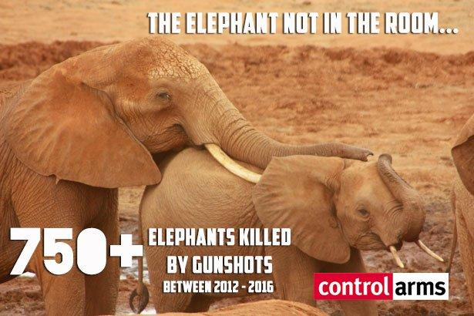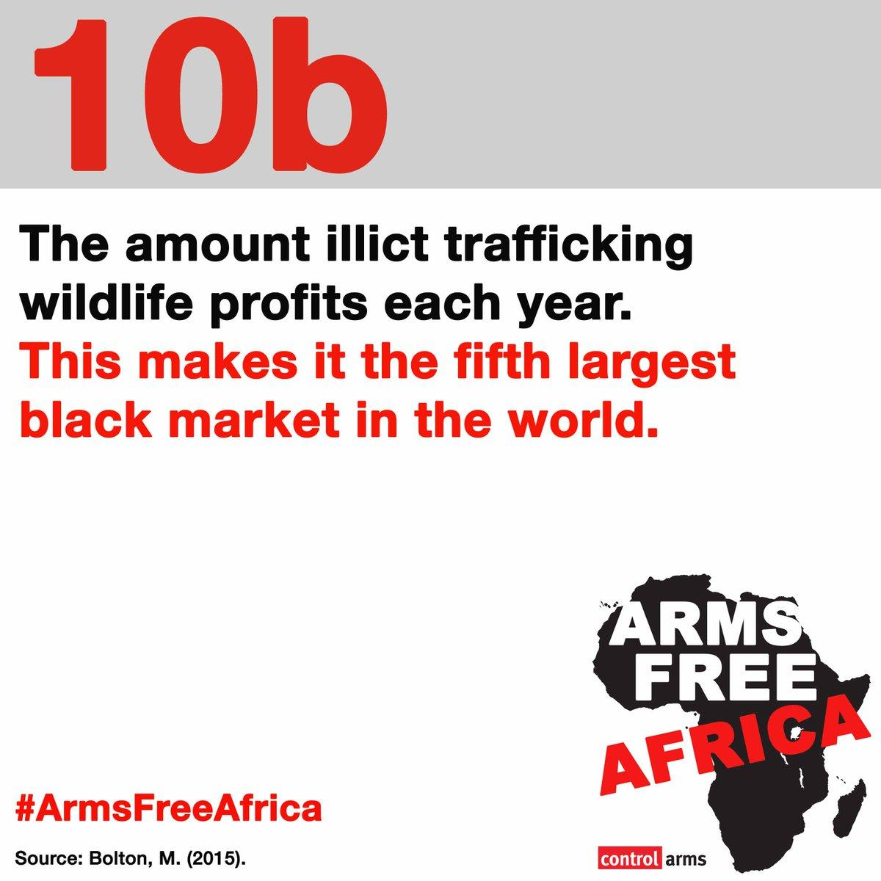

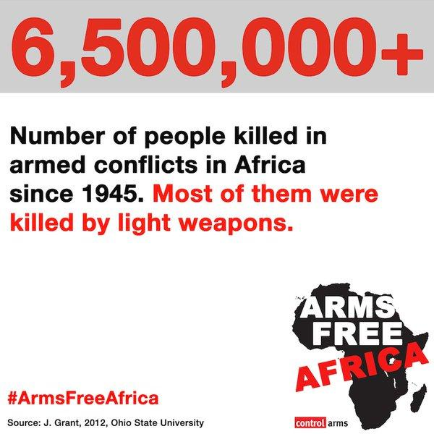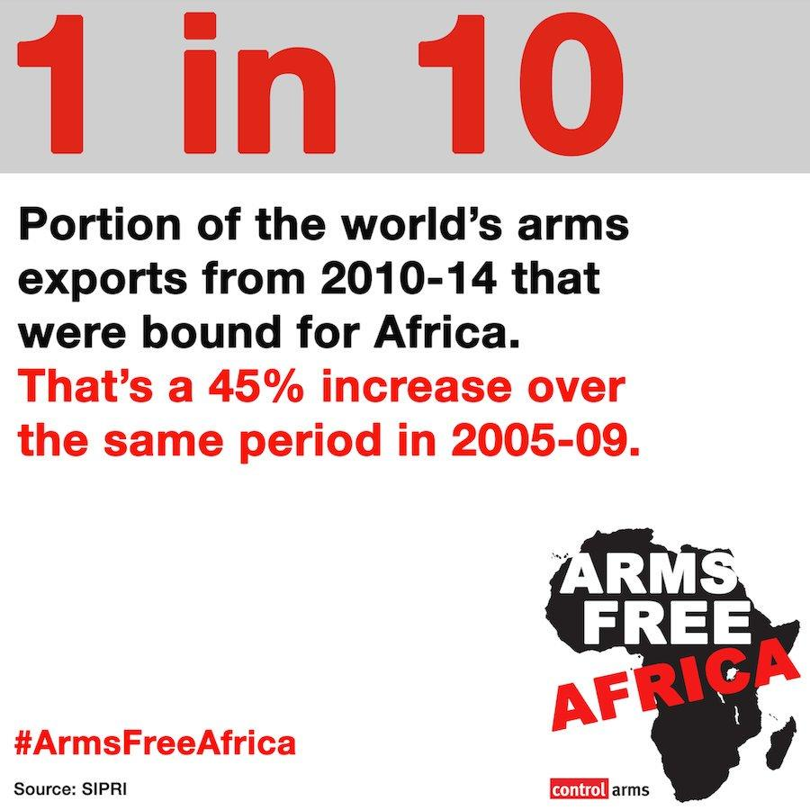

Control Arms continued to actively engage in social media throughout the project and created a #ArmsFreeAfrica toolkit for both Anglophone and Francophone countries and an online resource page for campaigners to use for their work. The Control Arms Secretariat shared weekly infographics (seen above) with Coalition members along with sample tweets and content distribution timelines for campaign actions. As with previous campaign actions, there was a higher rate of engagement from members with the prepared material than if they had to create it on their own. These materials distributed to more than 100 civil society representatives and activities were carried out in Ghana, Democratic Republic of Congo, Togo, and Kenya during the campaign. Control Arms members and partners were actively engaged, with tweets having an average of about 3500 impressions each.

In August 2016, Control Arms published “Tackling Terror: How the Arms Trade Treaty (ATT) Could Stop the Diversion of Arms and Ammunition in West Africa”. This report was launched at a side event with the African Union at CSP 2016 and distributed online through the Control Arms website and social media platforms including Twitter and Facebook.

Control Arms, in partnership with Amnesty International and other Coalition members, engaged in a photo action at CSP. The action included coalition members, many of whom are survivors of armed violence, and called on governments to be more transparent and work towards an #ArmsFreeAfrica.

Control Arms was also able to contract a consultant to draft and disseminate press releases, op-eds, advisories, and proactively engage with journalists. This complemented the work of the Secretariat staff and provided added immediate value to the coalition’s work and facilitated media coverage that would not have otherwise been obtained.

Impact & Achievement

The above activities successfully contributed to outcomes identified in the project proposal. In particular, the publication of “Achieving ATT Universalisation in Africa” helped to increase understanding for both governments and civil society of the obstacles to ATT accession or ratification facing African countries. This type of research will serve as the model for a key Control Arms activity during the 2017 portion of this project, which is to publish a similar paper for the CARICOM region. In both bilateral meetings and roundtable discussions, ways forward were identified and discussed with different stakeholders, including donor governments.

More than 50 government officials attended the side events co-hosted by Control Arms, therefore achieving the second proposed outcome of more than 25 government officials benefitting from the research and information presented during UNGA First Committee.

Throughout the course of the project, Control Arms’ social media presence continued to raise the profile of the ATT and highlight the Treaty’s goals and objectives to specific security concerns of the region. The creation of the toolkit as well as online distribution of research papers and reports enabled Coalition members in Africa to further disseminate the information to their organisations and reach wider audiences than the Control Arms Secretariat could on its own.

Risks & Challenges

One of the main challenges to this project was prioritization of the ATT by governments. Though many prospective States Parties are supportive of the Treaty, ongoing internal conflicts and other country priorities often take precedence over the ATT, therefore delaying the ratification or access process. Though the region gained 5 States Parties in 2016, bringing the total States Parties in the region to 22, that total fell short of the project goal of 30 African States Parties by the end of 2016.

Another challenge was obtaining overall media coverage for the campaign. With many higher profile issues happening during the time of the project, it was harder to get as much as press coverage compared to previous campaigns. It was especially helpful to have a press consultant available at these times and her work facilitated wider than expected coverage.

Expenses
YEAR 1

Exchange rate per received funds: 1 USD = 8.4464799657 NOK

 | Budgeted NOK Yr 1 | Received USD Yr 1 | Actual Expenses NOK Yr 1 | Variance (Budgeted – Actual = Variance)
Project Management | NOK91,172,62 | $10,794.16 | $10,794.16 | $0.00
Project Management | NOK91,172.62 | $10,794.16 | $10,794.16 | $0.00
Project Expenses | NOK75,500.00 | $8,938.63 | $8,938.74 | $0.11
Report publication (Printing, distribution)
CSP2 Side Event (Travel, venue rental, materials, catering, media) | NOK55,000.00 | $6,511.59 | $6,559.42 | -$47.83
Social media and Campaign Actions (Materials, media, distribution) | NOK20,500.00 | $2,427.04 | $2,379.32 | $47.72
Direct Eligible Costs | NOK166,672.62 | $19,732.79 | $19,732.90 | -$0.11
5% Admin | NOK8,327.38 | $985.90 | $985.90 | $0.00
TOTAL | NOK175,000.00 | $20,718.69 | $20,718.80 | -$0.11

YEAR 2

Amount: 125,000 NOK (100,000 NOK / $11,753.64 USD received; 25,000 NOK Remaining)

Dates: January - December 2017

Activities: In 2017, Control Arms sought to remind governments that the object and purpose of the Arms Trade Treaty was to 'reduce human suffering' around the world. From the #ReduceHumanSuffering social media campaign, to side events at the third Conference of States Parties (CSP 2017) and the 72nd UNGA First Committee to resources and reports, Control Arms aimed to shift the focus from procedural issues to substantive discussions around the implementation of and compliance with the Treaty’s provisions.

- Produce a resource on the links between the SDGs and the ATT

Both the Arms Trade Treaty (ATT) and the Sustainable Development Goals (SDGs) aim to make positive contributions to global society and development. Both instruments are thus comprehensively connected in shared principles, complementary processes, and mutually reinforcing activities. Building on a case study published in advance of the third CSP -“Goals not Guns: How the Sustainable Development Goals and the Arms Trade Treaty are Interlinked” - Control Arms developed a database that tracks and analyzes on a state-by-state basis how specific Sustainable Development Goal priorities relate to the ATT.

This database aims to assist arms control campaigners to broaden the discussion and increase awareness of how the effective implementation of the ATT will have a demonstrated and positive impact toward the achievement of a number of SDGs. This resource can also be employed to develop targeted ATT universalization and implementation messages and strategies, especially for countries and regional who are otherwise skeptical of the traditional arguments in favor of ATT universalization and implementation.

Currently under beta testing, the SDG/ATT database aims to become an open-source, collaborative and real-time resource. Currently, only those countries that have announced their SDG priorities and targets for the 2017 and 2018 are included in the database. And while it primarily tracks and analyses synergies between the ATT and Goal 16, it will expand to include Goal 5 on Gender Equality, Goal 11 on Sustainable Cities and Communities, and Goal 17 on Partnerships.

- Convene a side event at the 72nd UNGA First Committee

On 26 October 2017, Control Arms, with support from the Permanent Mission of
Trinidad and Tobago and SIPRI hosted a side event on Practical Links between the ATT, UNPoA and the SDGs. This event explored areas where the goals and content of the Arms Trade Treaty (ATT), UN Programme of Action on SALW (UNPoA), and the Sustainable Development Goals (SDGs) overlap.

Chairing the event, Charlene Roopnarine from the Permanent Mission of Trinidad and Tobago stressed the importance that the Caribbean Community, a region disproportionately affected by the illicit trade in arms and ammunition, attaches to the ATT, UNPoA, and the SDGs. The Conventional Arms Branch Chief of the UN Office of Disarmament Affairs, Daniel Prins, summarized how the effective implementation of the ATT and UNPoA can contribute toward meeting the targets set by the SDGs while also stressing how SDGs’ reporting requirements can improve the measurability of these instruments.

Providing a national perspective, Maria Paula MacLoughlin from the Permanent Mission of Argentina presented examples of cross-cutting measures taken by her government toward the achievement of SDG Target 16.4, including the adoption of a firearms restriction plan, the development of destruction procedures, and plans to destroy 70,000 weapons. Control Arms campaigner Stephen Mwachofi Singo from the Security Research Institute Center in Nairobi, Kenya also shared views, lessons learned and challenges from the implementation of these instruments. He particularly highlighted ways in which civil society can support these efforts and provided examples from Kenya.
Cindy Ebbs of Control Arms introduced a new ATT Monitor case study “Goals not Guns: How the SDGs and the ATT are interlinked”, and stressed the need to broaden the discussion and increase the awareness of the full range of linkages between the ATT and the SDGs. She detailed how targets beyond 16.4 are connected to the arms control agenda, including target 5.2, which seeks to “eliminate all forms of violence against all women and girls in the public and private spheres”, and targets 17.17 and 17.18 which “aim to strengthen statistics, data gathering, and assessment capacity”.
Glenn McDonald of Small Arms Survey expanded the focus of discussion to include four arms control instruments that can contribute to achieving target 16.4—the ATT, UNPoA, International Tracing Instrument (ITI) and the UN Firearms Protocol. Echoing Daniel Prins’ views, he noted that reporting under the international arms control instruments can support the gathering of data for indicator 16.4.2 as well as measure progress made in reducing illicit arms flows. Mark Bromley of SIPRI introduced the ATT-relevant Cooperation and Assistance Activities Database, a resource that can assist governments, UN agencies, and civil society in addressing national/regional interests and concerns while ensuring long-term sustainability of projects.
The Q&A session, brought forth positive feedback on the resources presented in this side event as well as a number of comments welcoming broader linkages between the ATT and other arms control instruments as well as the SDGs, including from New Zealand, Sweden and Antigua and Barbuda.

- Campaign action against armed violence

Control Arms employed social media to raise awareness and disseminate information about how the ATT can help reduce conflicts and armed violence around the world. In particular Control Arms’ online presence dedicated significant attention to the humanitarian consequences of arms supplied to the warring parties in Yemen and urged governments to apply the Treaty’s provisions to prevent arms transfers that risk being used to commit or facilitate violations of international human rights and humanitarian law. To this end, for every month during the 12-month grant period, Control Arms tweets on Yemen had the widest reach of all Control Arms tweets. Control Arms also published four web stories and three blogs on this issue, highlighting the need for governments to suspend arms supplies to warring parties in order to protect civilians.

In advance of CSP 2017, Control Arms launched a 10 day social media campaign on Facebook, Twitter and Instagram, to raise awareness about the Treaty’s object and purpose: to reduce human suffering. As this was a valuable opportunity to build momentum and engagement the Control Arms coalition members and partners, a social media toolkit, sample tweets, graphics and illustrations were disseminated to the members and partners in English, French and Spanish.

Launched on 01 September, the 10 day countdown to CSP 2017, highlighted key ways in which effective ATT implementation as well as accountability and transparency in the global arms trade can reduce human suffering. During this period, the Control Arms Twitter account earned 46,300 impressions and over 350 retweets, with each tweet receiving an average of 3000 impressions and 35 retweets. During the same period, the Control Arms Facebook page reached over 15,600 individuals. During CSP 2017 itself, the @ControlArms Twitter account reached new record numbers: an averaged 45,000 impressions per day and a total of 225.0k impressions. Noteworthy is also the fact that the #ArmsTreaty hashtag was trending in Geneva and New York for several of the CSP days.

On 11 September 2017, over 40 Control Arms campaigners from around the world held a photo media action outside the iconic Broken Chair Statue in front of the UN, to raise the profile of the ATT CSP process and called on ATT States Parties to remember the Treaty’s core goal, to ‘Reduce Human Suffering.’ As part of this action, each morning of CSP 2017, delegates were handed a postcard from one of 5 countries as they arrived at the plenary session.. Each postcard drew attention to the human suffering fuelled by the arms trade in 5 different countries and highlighted how effective ATT implementation can help to curb these concerns. Civil society representatives from Papua New Guinea, Jamaica, Yemen, South Sudan, and Honduras signed these postcards and urged governments to explore fully the linkages between the ATT and the Sustainable Development Goals, reduce armed violence and prevent the diversion of weapons.

Following CSP 2017, Control Arms launched a series of videos on social media to raise awareness and momentum around the ATT’s overall goal: to reduce human suffering. Each video features a Control Arms campaigner discussing why reducing human suffering is important to the him or her, and how the ATT can help achieve this goal. Radhya Almutawakel’s video was shared on 20 December 2017 to mark the 1000th day since the Yemen conflict begun. Ms. Almutawakel’s video reached over 4000 people on Twitter, over 2900 people on Facebook as well as 82 people on Instagram. Other published videos feature Elizabeth Kirkham of Saferworld and Cesar Jaramillo of Project Ploughshares. The campaign will continue in 2018 with the creation of new videos with campaigners at upcoming Working Group meetings and PrepComs.

Impact & Achievement

The above activities successfully contributed to outcomes identified in the project proposal. Both the database and the side event held at the UNGA First Committee contributed to increased understanding of the synergies between the SDGs and the ATT across several goals and targets, and highlighted where international assistance available for the ATT and the SDGs converge. More than 500 copies of the “Goals not Guns” paper were distributed to government officials and civil society during the 72nd UNGA First Committee meetings and more than 25 government officials were able to attend the side event to learn about this research and information in person, therefore achieving the second proposed outcome for Year 2.

Throughout 2017, Control Arms’ social media activities continued to raise awareness of the Treaty’s goals and objectives to specific security concerns in a region. By highlighting arms transfers and other developments related to areas currently devastated by war, Control Arms’ social media activities provided its followers with timely information and statistics about these regions and how the ATT can be effectively implemented to promote human rights as well as the Treaty’s overall goal: to reduce human suffering.

Risks & Challenges

Though the original targeted region for Year 2 of this project was CARICOM, the re-focus onto the SDGs and the ATT was very timely and relevant to current priorities of governments, as seen during the CSP and during UNGA First Committee. Continuity between the two grants was ensured through active engagement of CARICOM governmental representatives and civil society members in activities conducted during year two of this grant. For example, the UNGA First Committee side event was co-hosted in partnership with the Permanent Mission of Trinidad and Tobago. Ms. Charlene Roopnarine, representative from the Permanent Mission and Chair of the event, stressed the importance of effectively implementing both the ATT and the SDGs for CARICOM, in her opening remarks.

As is always a challenge, competing for media attention made it harder to get more press coverage compared to previous campaigns. Nonetheless, during the third CSP, Control Arms achieved significant international media coverage (for example The Guardian, Channel 4, Independent, Swissinfo.com, Nigerian Tribune, Neues Deutschland, Front Page Africa) with messages highlighting that the object and purpose of the ATT is to “reduce human suffering” and the need to address arms transfers in violation of the ATT.

Expenses

YEAR 2
Exchange rate per received funds: 1 USD = 8.5080026 NOK
*Remaining 100,000 NOK expenses estimated using this exchange rate

 | Budgeted NOK Yr 2 | Budgeted* USD Yr 2 | Actual Expenses* USD Yr 2 | Variance (Budgeted – Actual = Variance)
Project Management | 42,547.62 | 5000.89 | 5031.03 | -30.14
Project Management | 42,547.62 | 5000.89 | 5031.03 | -30.14
Project Expenses | 76,500.00 | 8991.54 | 8961.40 | 30.14
Report publication (Printing, distribution) | 9,000.00 | 1057.83 | 1143.05 | -85.22
CSP/First Committee Side Event (Travel, venue rental, materials, catering, media) | 55,000.00 | 6464.50 | 6349.28 | 115.22
Social media and Campaign Actions (Materials, media, distribution) | 12,500.00 | 1469.21 | 1469.07 | 0.14
Direct Eligible Costs | 119,047.62 | 13,992.43 | 13992.43 | 0.00
5% Admin | 5,952.38 | 699.62 | 699.62 | 0.00
TOTAL | 125,000.00 | 14692.05 | 14692.05 | 0.00

