Blow the whistle on tax secrecy!
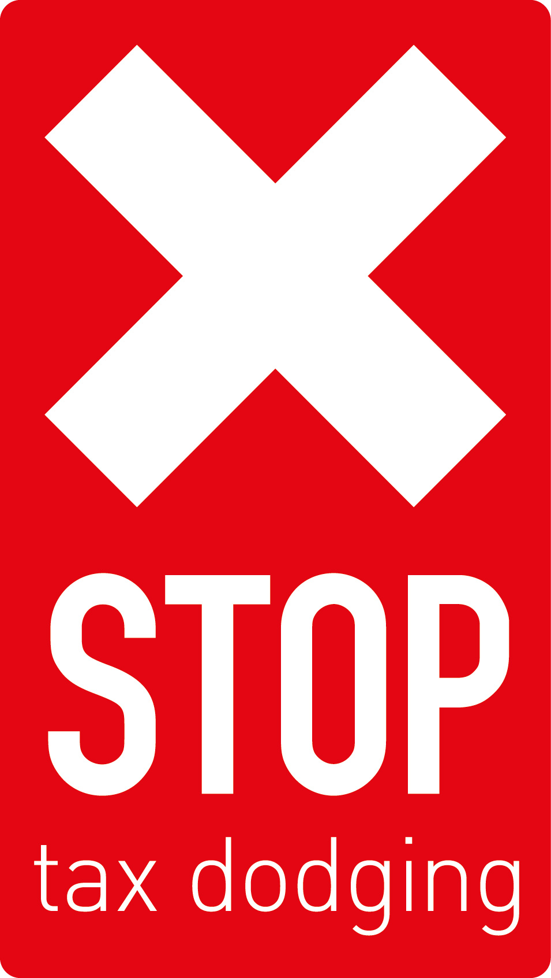
Your help is needed!

On 7 May the European Parliament votes on a proposal for public Country by Country Reporting. This is a chance to create true tax transparency for multinational companies in the EU. And it is much needed…

As #LuxLeaks revealed, European governments have introduced secrecy and tax laws that undermine corporate tax collection in developing countries. Those that expose this system risk being sent to prison.

Two weeks ago, on April 23, the French journalist Edouard Perrin was charged in Luxembourg for his role in exposing the corporate tax avoidance scandal nicknamed #LuxLeaks. Similar charges have been brought against the whistleblower Antione Deltour, who now risks several years in prison.

This shows just how twisted the lines of accountability are: Tax dodgers go free while fierce legal actions are taken against those who act on their conscience and in the interest of the public in both developed and developing countries.

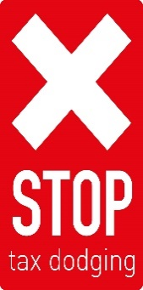
This corporate tax information should never have been secret in the first place – it should be part of public country by country reporting for multinational enterprises, and that’s what the European Parliament is now going to vote about. Only with public CBCR will developing countries be able to access the information they need to collect a fair share of corporate taxes. And only with public CBCR will we be able to hold corporations accountable.

It’s time to say STOP! Join us in a ‘Mass Whistleblowing’ and support our campaign for public Country by Country Reporting.

We will be hold a demonstration and photo opportunity outside the Luxembourg Embassy to blow the whistle on them and hand in a statement. Please sign up at the reception desk.

We will leave the conference centre by bus at 3.30pm Thursday 7 May for the action and will return at 5pm.

You can also support online!
Please tweet the European Parliament ahead of their important 7 May vote on Country by Country Reporting. Suggested tweet:
“We need #TaxTransparency: Vote yes to Country by Country Reporting in Shareholders Rights Directive to #StopTaxDodging.”

Direct the tweet at any or all of the European Parliament and the accounts of MEPs who are key to getting the proposal passed: @Europarl_EN @maryhoneyball @JeanMarieCAVADA
@CeciliaWikstrom @GiovanniToti @AndrzejDuda @AxelVossMdEP @SajjadKarimMEP @Cofferati @LauraFerraraM5S @Evelyn_Regner @lidiageringer

If you haven’t already, please also visit https://support-antoine.org/en/ and sign the petition to support the whistle blower Antoine Deltour.

